Customer Shopping Behavior Analysis

Project Overview
The business lacked visibility into customer behavior; who spends the most, product performance across categories, discount dependency, and how subscription status affects revenue. This limited the ability to improve marketing, pricing, and retention strategies.

Dataset Summary
- Rows: 3,900 - Columns: 18 - Key Features:
- Customer demographics (Age, Gender, Location, Subscription Status)
- Purchase details (Item Purchased, Category, Purchase Amount, Season, Size, Color)
- Shopping behavior (Discount Applied, Promo Code Used, Previous Purchases, Frequency of
Purchases, Review Rating, Shipping Type)
- Missing Data: 37 values in Review Rating column

Exploratory Data Analysis using Python
The dataset of 3,900 transactions was cleaned and analyzed using Python:
- Data Loading: Imported the dataset using pandas.

- Initial Exploration: Used df.info() to check structure and .describe() for summary statistics.
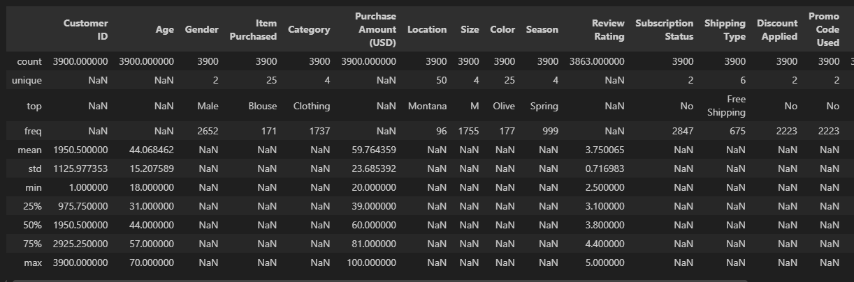
- Missing Data Handling: Checked for null values and imputed missing values in the Review Rating column using the median rating of each product category.
- Column Standardization: Renamed columns to snake case for better readability and documentation.
- Feature Engineering:

○ Created age_group column by binning customer ages.

○ Created purchase_frequency_days column from purchase data.

- Data Consistency Check: Verified if discount_applied and promo_code_used were redundant; dropped promo_code_used.

- Database Integration: Connected Python script to PostgreSQL and loaded the cleaned DataFrame into the database for SQL analysis.

Data Analysis using SQL (Business Transactions)
A structured analysis was performed in PostgreSQL to answer key business questions:
- Revenue by Gender – Compared total revenue generated by male vs. female customers.
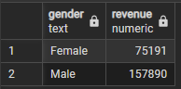

- High-Spending Discount Users – Identified customers who used discounts but still spent above the average purchase amount.
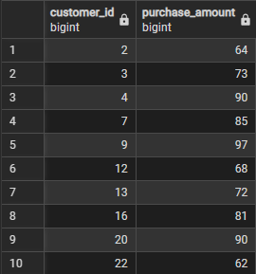

- Top 5 Products by Rating – Found products with the highest average review ratings.

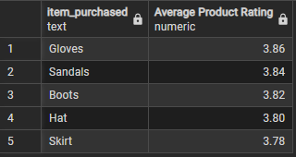
- Shipping Type Comparison – Compared average purchase amounts between Standard and Express shipping.
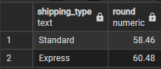

- Subscribers vs. Non-Subscribers – Compared average spend and total revenue across subscription status.
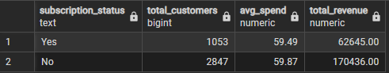

- Discount-Dependent Products – Identified 5 products with the highest percentage of discounted purchases.
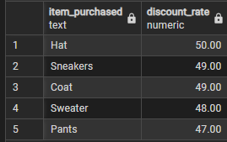

- Customer Segmentation – Classified customers into New, Returning, and Loyal segments based on purchase history.
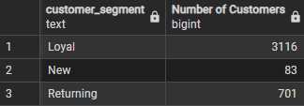

- Top 3 Products per Category – Listed the most purchased products within each category.
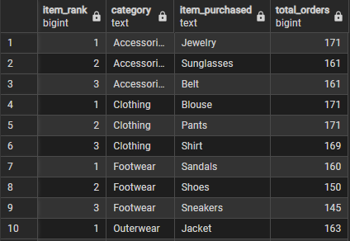

- Repeat Buyers & Subscriptions – Checked whether customers with >5 purchases are more likely to subscribe.
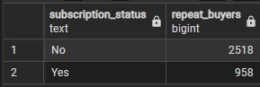

- Revenue by Age Group – Calculated total revenue contribution of each age group.
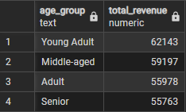

Dashboard in Power BI

Built an interactive dashboard in Power BI to present insights visually.
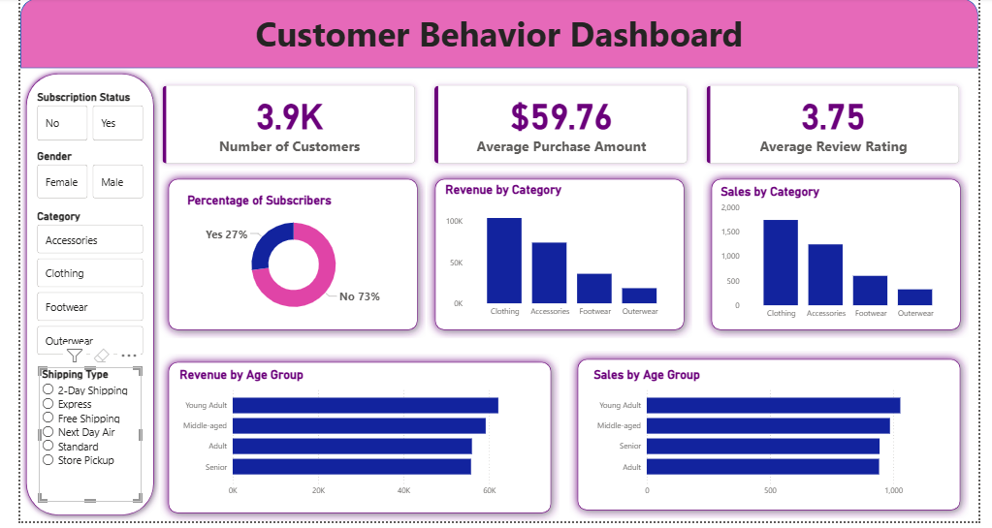

Business Recommendations

- Boost Subscriptions – Promote exclusive benefits for subscribers.

- Customer Loyalty Programs – Reward repeat buyers to move them into the “Loyal” segment.

- Review Discount Policy – Balance sales boosts with margin control.

- Product Positioning – Highlight top-rated and best-selling products in campaigns.

- Targeted Marketing – Focus efforts on high-revenue age groups and express-shipping users.

